**Proposing Energy-Efficient Urban Spaces using IoT and Data Visualisation**

*Submitted in partial fulfilment of the requirements for the degree of*

**Bachelor of Technology**

**in**

**Computer Science and Engineering**

*by*

**NITIN PRAMOD RANJAN**

**18BCE0272**

**Under the guidance of**

**Dr B Gladys Kiruba Gnana**

**SCOPE**

**VIT, Vellore**



June, 2022

**DECLARATION**

I hereby declare that the thesis entitled “Proposing Energy-Efficient Urban Spaces Using IoT and Data Visualisation" submitted by me, for the award of the degree of Bachelor of Technology in Programme to VIT is a record of bonafide work carried out by me under the supervision of Dr B Kiruba Gnana.

I further declare that the work reported in this thesis has not been submitted and will not be submitted, either in part or in full, for the award of any other degree or diploma in this institute or any other institute or university.

Place : Vellore

Date : 26-05-2022

**Signature of the Candidate**

**CERTIFICATE**

This is to certify that the thesis entitled “Proposing Energy-Efficient Urban Spaces Using IoT and Data Visualisation” submitted by **Nitin Pramod Ranjan & 18BCE0272**, **SCOPE**, VIT University, for the award of the degree of *Bachelor of Technology in Computer Science and Engineering*, is a record of bonafide work carried out by him under my supervision during the period, 01. 12. 2018 to 30.04.2019, as per the VIT code of academic and research ethics.

The contents of this report have not been submitted and will not be submitted either in part or in full, for the award of any other degree or diploma in this institute or any other institute or university. The thesis fulfills the requirements and regulations of the University and in my opinion meets the necessary standards for submission.

Place : Vellore

Date : 06-05-2022

**Signature of the Guide**

**Internal Examiner External Examiner**

Head of the Department

Computer Science and Engineering

# ACKNOWLEDGEMENTS

I would like to express my sincere gratitude to Dr B Kiruba Gnana, SCOPE, VIT, Vellore for accepting our project idea and being our guide for the same. I would also like to thank my team-members for being supportive of the each-other’s ideas and helpful in bringing the final project to a fruition.

Finally, I would like to thank VIT University, Vellore for providing me with a chance to work on this idea and to provide me with a platform to express it.

Nitin Pramod Ranjan

18BCE0272

SCOPE

Date: 25-05-2022

Place: Vellore

# Executive Summary

Global warming, energy shortage and housing – are the three of the most haunting problems to the civic administration across the planet. This problem, though, can be solved to a great extent using technology, is not looked upon a lot owing to socio-political considerations and the lack of acceptance of technology-based solutions en masse.

The project proposed in this document is an algorithm and its demonstration wherein data of energy consumption and wastage is collected from the users through household and office equipment connected to an IoT cloud, this data is then analysed and the users are suggested modernised and economically feasible equipment that can automate their place and also reduce both wastage of electricity and costs involved with it. The technology used in the project proposed is Machine Learning, Statistical Analysis using Python, Data Visualisation, cloud storage and some basic IoT devices.

The whole process is transparent, easy to program on a computer, as is visible from the simulation demonstrated in the project and is thus likely to gain not only support from the administration but also the people.

# Table of Contents

ACKNOWLEDGEMENTS 8

Executive Summary 9

Table of Contents 10

List of Figures 13

List of Tables 14

List of Abbreviations 15

1. INTRODUCTION 16

1.1. Theoretical Background 16

1.2. Motivation 16

1.3. Objective 16

2. PROJECT DESCRIPTION AND GOALS 17

3. TECHNICAL SPECIFICATION 18

3.1. Overview 18

3.2 Functional Requirements 18

3.2.1 User characteristics 18

3.2.2. Assumption &amp; Dependencies 18

3.2.3. Domain Requirements 18

3.2.4. User Requirements 18

3.3. Non-Functional Requirements 18

Product Requirements 18

3.4. Operational Requirements 19

3.5. System Requirements 20

3.5.1. H/W Requirements 20

3.5.2. S/W Requirements (details about Application Specific Software) 20

4. DESIGN APPROACH AND DETAILS 21

4.1. Design Approach, Materials and Methods 21

4.2. Constraints, Alternatives and Tradeoffs 22

5. SCHEDULE, TASKS AND MILESTONES 23

6. PROJECT DEMONSTRATION 24

6.1. The Proposed Algorithm 24

6.2. Steps involved in detail 25

6.3. The CISCO Packet Tracer Demonstration 26

6.3.1. Basic set of Modules and sensors used 28

6.3.2. Additional Components needed 31

6.3.3. Protocols Used 31

6. 4. Cost Estimation 35

7. RESULTS, COST ANALYSIS AND DISCUSSION 36

7.1. Statistical Evaluation of the Dataset 36

7.1.1. Indian Dataset 36

7.1.2. New York Dataset 38

7.1.3. London Dataset 39

7.2. The results obtained from the CISCO Packet demonstration 40

7.3. Cost Estimate of Using the Proposed Algorithm in said scenarios 40

7.3.1 Component and maintenance Cost for the Simulated Office 40

7.3.2. Extra Installation Cost for the simulated Office 42

**7.3.3.** Comparison against real-time costs 43

7.3.4. Summarising the Simulation 43

8. SUMMARY 45

9. REFRENCES 46

APPENDIX A 49

Basic Terminologies Involved in The Document 49

Selected Literature Survey 50

Link to tableau presentation 60

# List of Figures

Figure 1 Task Breakdown 23

Figure 2 The proposed Algorithm 24

Figure 3 The layout of the smart office model proposed to simulate the algorithm 26

Figure 4 All the environment variables and the IoT devices can be accessed at a common laptop/mobile/computer available with the office manager. 27

Figure 5 20 environmental variables were simulated in CISCO packet tracer 31

Figure 61 The music speaker 34

Figure 7 Mode vs median for Indian Data 36

Figure 8 Mean, Median and mode for Indian Energy Consumption Data 36

Figure 9 Linear Regression Used on Indian Data (For source Code, refer Appendix A) 37

Figure 10 IIT Mumbai Energy Consumption by phase (hour wise) 38

Figure 11 Energy Consumption pattern for New York 38

Figure 12 Energy Consumption Pattern for London 39

# List of Tables

TABLE 1: Project Scenarios in the Simulated Project, *Page 28*

TABLE 2: IoT Components Used in the Simulated Scenario, *Page 30*

TABLE 3: Results with Estimating Energy Consumption in the Indian picture, *Page 37*

TABLE 4: Observations with Estimating Energy Consumption in New York, *Page 39*

TABLE 5: Observations with Estimating Energy Consumption in London, *Page 40*

TABLE 6: IoT Components in the simulated scenario, their procurement costs and maintenance costs in India, *Page 41*

TABLE 7: IoT or electric devices to be installed without any foreseeable maintenance cost (in the simulated scenario), *Page 42*

# List of Abbreviations

US – United States of America

GoI – Government of India

ML – Machine Learning

NN – Neural Network

LSTM – Long Short-Term Memory

ARIMA - autoregressive integrated moving average

MQTT – MQ Telemetry Transport

# INTRODUCTION

## Theoretical Background

Smart Cities are becoming a focus of governments all over the world. They are supposed to be a delicate balance of economics, technology and public planning. However, free spaces to build new cities is a big problem for most sovereign states, smart cities projects are replacing classical infrastructure in existent urban areas.

Additionally, urban regions alone account for 60-80 percent of the total greenhouse gas emissions on the planet and are responsible for the consumption of 80 percent of the global energy. This involves heating, ventilation, air conditioning, lighting, and other major appliances. And as per independent research conducted by the IBM, seven-tenths of the world population shall live in cities by 2050 while 50% of global energy shall be consumed by the buildings in the cities alone.

## Motivation

City officials and governments across the globe have struggled so far to effectively analyse, visualise, and translate data from thousands of buildings into policy and program recommendations – partly due to the issue in logistics, partially due to economic and political constraints. Computers, however, provide not only with tools that can be used to benchmark consumption and supply but also to develop models that can compare and demonstrate impacts of energy-efficiency based improvements on the same.

 Countries all over the world have also pledged to become carbon neutral or carbon negative before the end of the first half of the 21st century. And governments are increasingly trying to fit both a smart city and green energy resources like the sun and the wind in one single pipeline.

## Objective

This project aims to study patterns of energy consumption and related costs and to further suggest IoT-based solutions to improvise upon the same by-

1. Visualising energy consumption of buildings in an urban setup.
2. Developing a computer-aided benchmark and base

# PROJECT DESCRIPTION AND GOALS

The project aims to solve the problems associated with availing IoT to general public as a means of accelerate the smart city projects that governments all over the planet have adopted since the author, after studying the available research in the field concluded that:

1. Most of the existing research leans greatly on the theoretical end of the subject matter.
2. Most of the existing literature is very specific to the dataset chosen. And these datasets often focus on a single city or a single region alone.
3. Very little research focuses on making the products more acceptable and usable to the people en masse and give political and economic incentives to actually bring forth the research to common use.

This project is aimed to create a real-time algorithm-like model that fulfilled the following -

1. Using models of machine learning and statistics to visualise energy consumption of buildings in an urban setup.
2. Developing a computer-aided benchmark and baseline for energy efficiency of buildings in cities.
3. Aiding in the implementation of the following UNDP goals –

Goal 7: Affordable and Clean Energy;

Goal 8: Decent Economic Growth

Goal 11: Sustainable Cities and Communities;

Goal 12: Responsible Consumption and Production; and

Goal 13: Climate Action

Finally, the authors shall demonstrate the project on various sets of data, trying to establish the fiscal feasibility of the same on some real-world situations. For the thus stated purpose, the authors chose the cities of –

1. New York;
2. Mumbai; and
3. London

And the special case of the state of Texas in the USA due to its climate and geographical location.

# 3. TECHNICAL SPECIFICATION

## 3.1. Overview

The current governments have made little or no strides in promoting IoT as a solution to the problems of global warming, energy over-exploitation and wastage of the same.

## 3.2 Functional Requirements

### 3.2.1 User characteristics

1. The primary user is expected to be a government or public administrator.
2. Common households can too use this algorithm, but the authors do not expect them to be versed with technicalities like benchmarking and visualisation.

### 3.2.2. Assumption &amp; Dependencies

1. The user has the necessary visualisation and statistical tools.
2. The user and the hub have a communication paradigm in place.

### 3.2.3. Domain Requirements

1. A cluster head selection algorithm depending on the scale of data and nodes involved.
2. A communication channel to retrieve equipment and electricity usage report and data directly from the buildings to the government servers.

### 3.2.4. User Requirements

1. Easy to incorporate.
2. Very little breach of privacy.

## 3.3. Non-Functional Requirements

### Product *Requirements*

1. **Efficiency (in terms of Time and Space) -** The steps involving benchmarking and calculations are very efficient in both time and space. The datasets only need to be in the form of a simple table. The calculations do not need any special tool or hardware. However, if visualisations are to be stored, the space and time required are greater. Depending on the hardware and software requirements specified, the efficiency should be high and worthy of incorporating into administration.
2. **Reliability -** All the modelling of IoT solutions are very personalised and hence the reliability of the algorithm has only as many problems as human error can allow.
3. **Usability -** The project is specific to urban spaces like residential buildings and offices.
4. **Implementation Requirements (in terms of deployment) -** An agreement between the users and the civic authorities would be good. And a mecha person versed in basic use of computers and knows how to connect to bluetooth or WiFi would be sufficient to install devices.
5. **Engineering Standard Requirements-** A consumer cell to ensure that early grievances are met with fast action so that people adopt the technologies quickly. All devices installed must pass safety regulation.

## 3.4. Operational Requirements

1. **Economic -** The project is economically feasible and actually creates economic incentives for its adoption.
2. **Environment & Sustainability -** The algorithm when employed in urban spaces should provide a sustainable means of energy and cost optimisation for a long run. This in turn is also good for the environment.
3. **Social & Political -** The economic incentives created by the project in terms of long-term energy cost optimisations and the long-term positive effect on environment should create social and political incentives for its adoption as well.
4. **Legality -** The user’s energy usage and equipment-usage patterns shall be tracked. No other form of data is required to perform the process. So, a simple agreement between the civic authorities and users should suffice.
5. **Inspectability -** The packet tracer demonstration proves that the project components are open to audit and inspection in real time to both civic admins and the household or office owners.

## 3.5. System Requirements

### 3.5.1. H/W Requirements

1. A computer with RAM greater than 16GB and a hard disk with at least 256GB free storage shall be sufficient for the data of an entire city.
2. IoT devices depending on the scope and scape of installation

### 3.5.2. S/W Requirements (details about Application Specific Software)

1. Python 3.8 or above
2. R can be used too, but python is far superior in data visualisation tools.

# 4. DESIGN APPROACH AND DETAILS

## 4.1. Design Approach, Materials and Methods

The aim of the project being the establishment of a methodology around which a civil administration can function, the primary challenges involved –

1. Studying a large amount of data;
2. Establishing patterns of energy use – both seasonal and overall;
3. Working out a methodology;
4. Making it cost-efficient;
5. Checking compatibility with tools/solutions already available;
6. Making it transparent, easy to audit and control.

To begin with, the study of data needed a collection of lot of official data to keep up with the objective of the algorithm being of primary use to civil administration. For this reason, the following datasets were considered –

1. Energy consumption in India by state, 2012-2019 (Government of India)
2. Energy Wastage in India by State, 2011-2019 (Government of India)
3. Energy Production in India by source and state, 2012-2019 (Government of India)
4. Energy Consumption on the USA East Coast, 2001-2020, US Department of Energy
5. Energy Consumption in New York City, 2001-2020, US Department of Energy
6. Seasonal energy Consumption in London Metropolitan region, UK
7. World Energy Production by source, 1978-2020
8. World Energy Production by source against GDP PPP 2010-2020

The only constraint in the project was the lack of any real subject to experiment on. So, to understand the energy consumption at a more subtle level, we used the IIT Mumbai dataset for energy consumption of an IIT Mumbai building, hourwise for over 30 days. This dataset is very granular and has a phase-wise record of energy usage over the said period.

These datasets were then visualised on

1. Tableau; and
2. Python

to establish patterns and statistical benchmarks on the same. This task also involved the use of ML based benchmarking methods, so that both the mentioned methodologies be compared.

Finally, these benchmarks allowed the authors to estimate other parameters like cost-building and best tools for large-scale use.

## 4.2. Constraints, Alternatives and Tradeoffs

The only constraint in the project was the lack of any real subject to experiment on. This was the primary reason for using the IIT Bombay dataset. Other than that, one constraint, the other was obvious lack of computational resources to expand the datasets.

The author also would like to point out that the project proposed in the document is but the algorithm and hence, when deployed on a large server with data points equivalent to the population of a small city or town and with the granularity of a household, the means to assess the data might change.

# 5. SCHEDULE, TASKS AND MILESTONES

The primary set of tasks can be broken down to –

1. Data Gathering;
2. Data Analysis;
3. Model Comparison;
4. Application; and
5. Preparation of final report

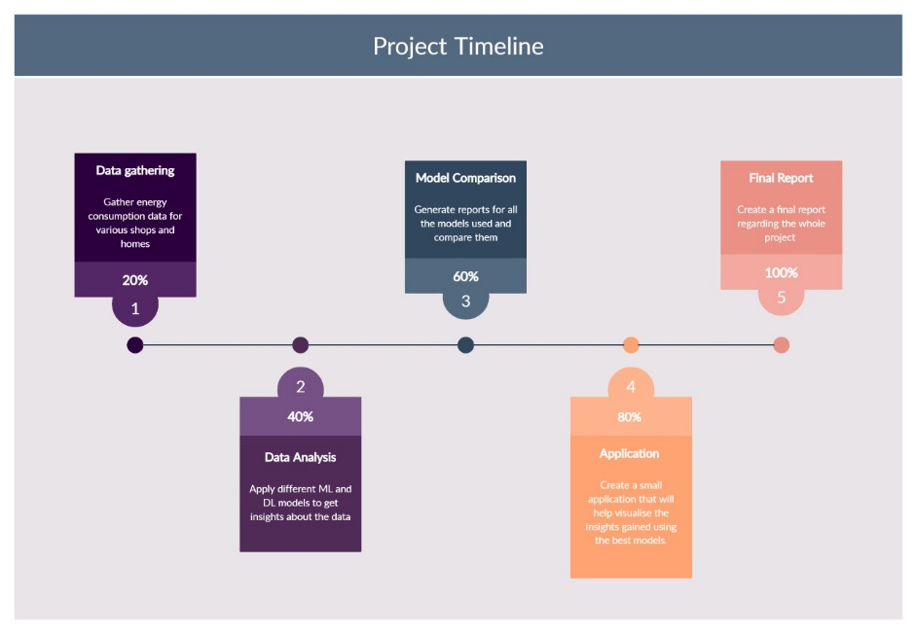

Figure 1 Task Breakdown

The schedule for the same was –

* December 2021 – Data Collection and studying Available Literature (check references and appendix A)
* January-March of 2022 – Data Analysis and Model Comparison
* April-May, 2022 – Studying Application using real-world data and estimating costs of application
* May, 2022 – Report Preparation

# 6. PROJECT DEMONSTRATION

## 6.1. The Proposed Algorithm

The following Algorithm was arrived upon –

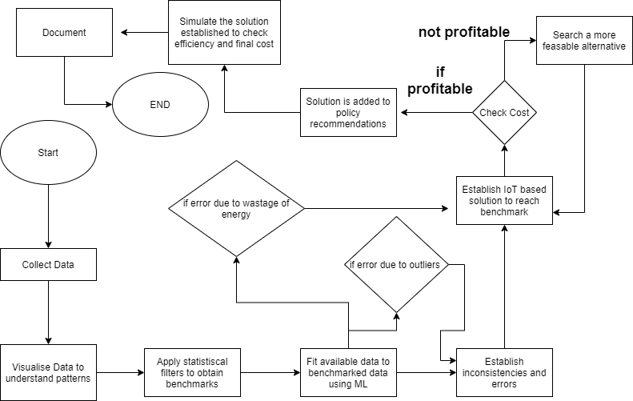

Figure 2 The proposed Algorithm

The algorithm is simple to follow and easy to deploy in a computer as a program. It is also very easy to set it up on local servers given that the number of steps involved are very less. Installing them into local servers would also mean that the task of evaluating millions of households can be distributed into several smaller groups.

## 6.2. Steps involved in detail

**1. Collection and visualisation of data –**

**The tools:** Tableau and Python.

Tableau is used to create interactive dashboards in order to consolidate all data. This step is to understand –

a) The most common forms of energy used in cities.

b) The way in which energy consumption has changed over years, thus predicting the patterns of future.

c) The power consumption pattern in buildings in order to prepare benchmarks for the same.

**Note:** *The datasets we are using are standard government datasets when it is concerned with energy consumption and its sources. For the purpose of benchmarking real urban data, we have used datasets separately generated by IIT Bombay and University of Boston respectively. This allows the study of two different countries with completely different energy usage patterns. Both the datasets have two parts –*

* + 1. The magnitude of phase voltages; and
    2. The power consumption with respect to each phase; over a period of 3 months.

Tableau Link: <https://public.tableau.com/views/EnergyTrendsViz/CoverPage?:language=en-US&:display_count=n&:origin=viz_share_link>

India Data Exploratory: <https://www.kaggle.com/code/nitinr2510/indiadataexploratory>

**2. Statistical Analysis of Data –**

**Tools:** Python

Step is performed to estimate measures like mean, median, mode, variance and deviation etc. in the data. The most prominent and recurrent derived values shall serve as the benchmarking criterion.

*In this project report, we have considered the central tendencies - mean, median, mode followed by ML algorithms that include ARIMA, LSTM and XGBoost.*

**Note:** Since the project aims at creating a model where energy usage habits are studied, in a real-life model of the smart city, the city council/municipal corporation shall receive all the energy usage data in real time through IoT and cloud.

London Data using LSTM and ARIMA: <https://www.kaggle.com/code/nitinr2510/energy-consumption-forecast>

Applying Regression on Indian Data: <https://www.kaggle.com/code/nitinr2510/regression-indian-energy>

**3. Simulation –**

**Tools:** Cisco Packet Tracer

Since the project is based on an urban landscape, it is important to simulate it to find if it is technologically possible.

## 6.3. The CISCO Packet Tracer Demonstration

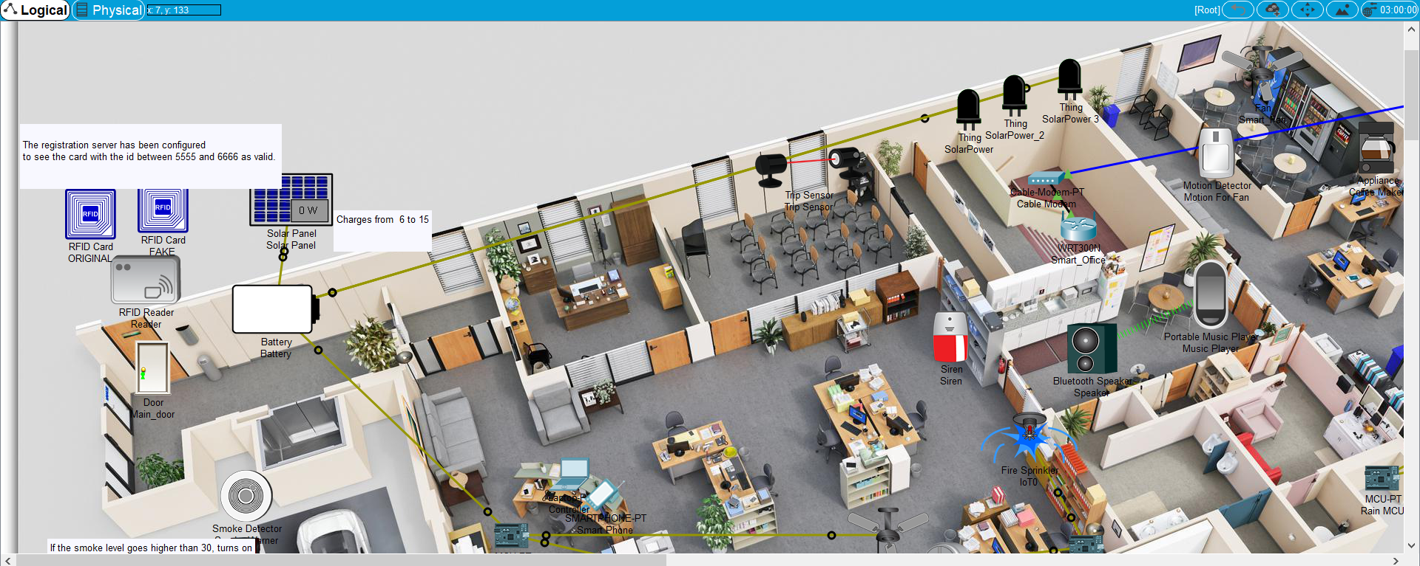

Figure 3 The layout of the smart office model proposed to simulate the algorithm

This is to create an IoT enabled space – an office - that is the most common environment around the world to show the feasibility of the same. The author and his team also ensured that the project is transparent to the stakeholders by ensuring a mobile app that can monitor all connected devices (figure 4).

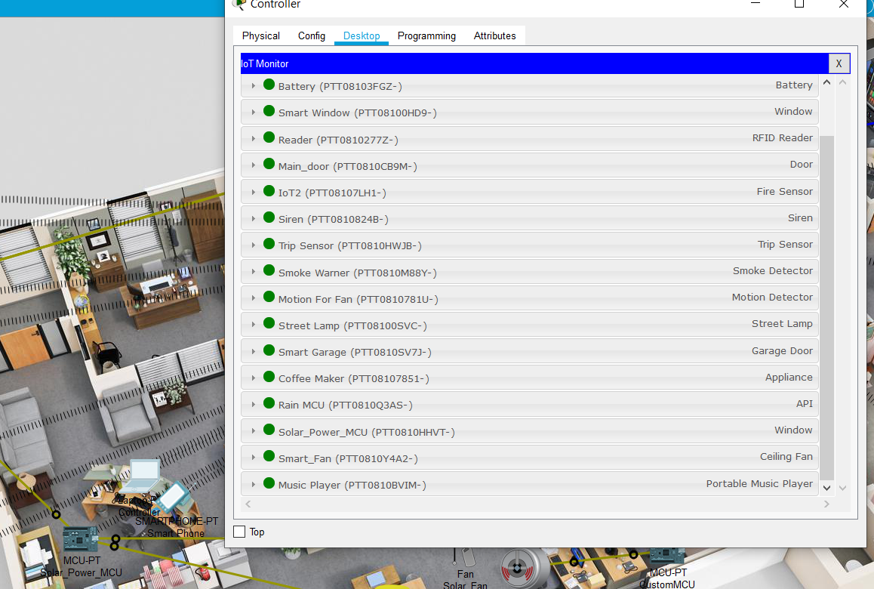

Figure 4 All the environment variables and the IoT devices can be accessed at a common laptop/mobile/computer available with the office manager.

### 6.3.1. Basic set of Modules and sensors used

**TABLE 1: Project Scenarios in the Simulated Project**

|  |  |  |
| --- | --- | --- |
| **Project Scenario** | **Reason for Introduction** | **Sensors/Actuators Used** |
| Automated Door Lock | To introduce automation in door locking/unlocking and eliminate doors as a point of contact and hence probable hotspot of infection | RFID chip and scanners. |
| Automated Window | To introduce automation in window opening/closing and eliminate window as a probable hotspot of infection | ***Sensors:*** Rain sensor, Photo sensor  ***Actuators:*** The window lock, automated screw to close/open window |
| Solar Charged Battery | To introduce cost-efficiency in the project | Solar Cells |
| Theft Protection Mechanism | 1. To reduce the possibility of a loss to the company. 2. To introduce cost efficiency by reducing the number of guards required. 3. Reducing number of guards reduces the possible chances of contact | ***Sensor:*** Trip or motion sensor  ***Actuator:*** Siren |
| Automated Coffee and Fan/AC | To eliminate the possibility of coffee machine or the fan/AC switch being a hotspot for infection | ***Sensor:*** Trip or motion sensor  ***Actuator:*** 1. Coffee dispenser  2. Fan/AC |
| Entertainment System | To introduce entertainment in the office while not adding to the possibility of an infection | ***Sensor:***  The mobile receiver and transmitter connected via bluetooth to the music player  ***Actuator:*** The music player + Speaker |
| Automated Street Lamp | To introduce vision near the organisation premises early in the day and then in the evening and night to facilitate better garage management | ***Sensor:*** Photo sensor  ***Actuator:*** The lamp bulb/LED |
| Automated Garage | To introduce automation in garage maintenance while reducing the possibility of human touch/contact. | ***Sensor:*** RFID sensors and Motion sensor  ***Actuator:*** Garage door |
| Fire Alarm + Sprinkler | To protect the economic and intelligent resources of the organisation | ***Sensor:*** Infrared Heat detector  ***Actuator:*** Siren + Water Sprinkler. |

**TABLE 2: IoT Components Used in the Simulated Scenario**

|  |  |  |  |
| --- | --- | --- | --- |
| **Sr. no.** | **Sensors/**  **Network devices used** | **Working Principle/**  **components** | **Application used in** |
|  | *WRT300N Router* | IEEE 802.11n protocol | Central hub for all IoT devices used in the scenario |
| 2. | RFID | Scanner + Antenna | Used for maintaining attendance and garage admission. |
| 3. | Rain Sensor | Resistive dipole based on moisture on the nickel poles on the sensor chip. | Used to find rains and high speed winds to open and shut the window automatically |
| 4. | Photo Sensor | Resistive dipole based on the light energy received by the semiconductor used | Receives light has an output circuit used to provide electrical energy |
| 5. | Solar Panels | photovoltaic effect | Uses the sensor and the solar cells to develop photo electricity |
| 6. | Trip Sensor | Passive IR sensor in fire detection,  Active IR sensor in Theft prevention modules | If the motion sensor is tripped the alarm rings and sends a message to the respective authorities. |
| 7. | Smoke sensor | A radioactive material, usually depleted Uranium or Radium is sandwiched between semiconductors. The radioactive element reacts with smoke and conductivity suddenly increases that rings the alarm. | Detects the CO2 in the environment and call in the required function . |

### 6.3.2. Additional Components needed

Two custom-programmable MCUs or microprocessors. They have been used to:

1. Ensure that the fire water sprinkler water reservoir is maintained.
2. Ensure that the rain sensor converts its series resistance to parallel as soon as water touches it, increasing conductivity manifolds and facilitating the closing of windows. Similarly, as soon as the water contact is broken off, the sensors reopen the window and set resistance to series.

A laptop / mobile / computer to manage the IoT structure through a MQTT facilitated cloud.

### 6.3.3. Protocols Used

1. **Bluetooth**: Bluetooth has been used as the primary protocol for connectivity in the kitchen to play music.
2. **WiFi 4.0:** WiFi4.0, which has been referred to as its parent protocol IEEE802.11n has been used as the protocol to connect all IoT devices to the WRT300N router. This is done to reduce the possibility of dead ends.
3. **MQTT:** MQTT has been used as the primary protocol to connect the office server to a larger organisational cluster. This is done to facilitate network stability even during limited bandwidth and constrained weather conditions.

Snips of the demonstration are as follows -

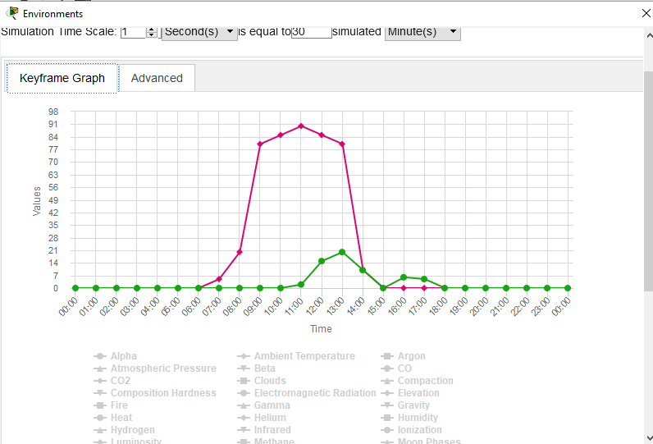

Figure 5 20 environmental variables were simulated in CISCO packet tracer

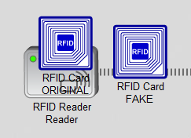

Figure 6 RFID CARD and READER in action

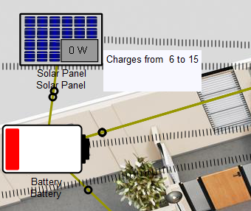

Figure 7 The solar powered battery in charge

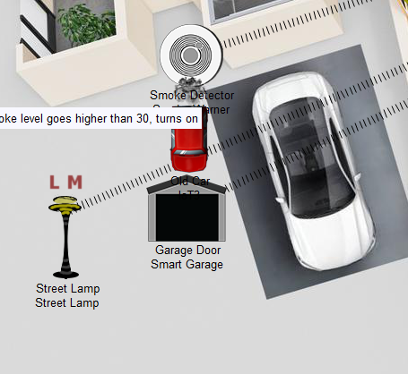

Figure 8 Smart Garage in action. The door is open and the car emits smoke.

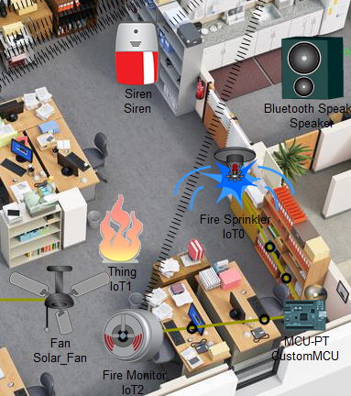

Figure 9 Motion sensor and fire alarm in action

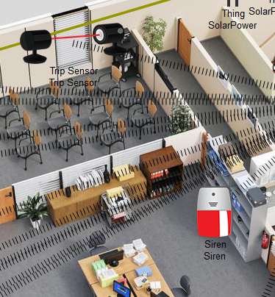

Figure 10 The trip sensor i.e. the theft detection module in action

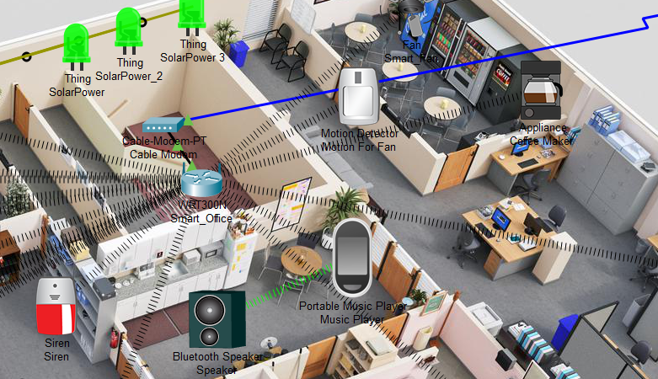

Figure 61 The music speaker

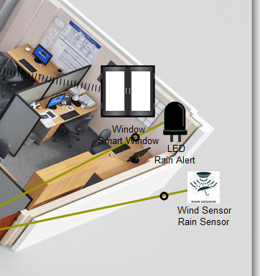

Figure 12 The smart Window module

## 6. 4. Cost Estimation

It is important that the IoT tools are not only compatible in terms of technology. But it must also be economically feasible. So, this step involves making them feasible for civilians with respect to the real time prices of IoT devices and machinery in the world. The results shall then be compiled into a report and a research paper be proposed using the same.

The cost estimates are discussed in section 7.

# 7. RESULTS, COST ANALYSIS AND DISCUSSION

*The tables in this section discuss the energy consumption estimates for the years 2020-’21.*

## 7.1. Statistical Evaluation of the Dataset

### 7.1.1. Indian Dataset

The following are the observations for determining central tendencies in the Indian datasets for energy consumption:

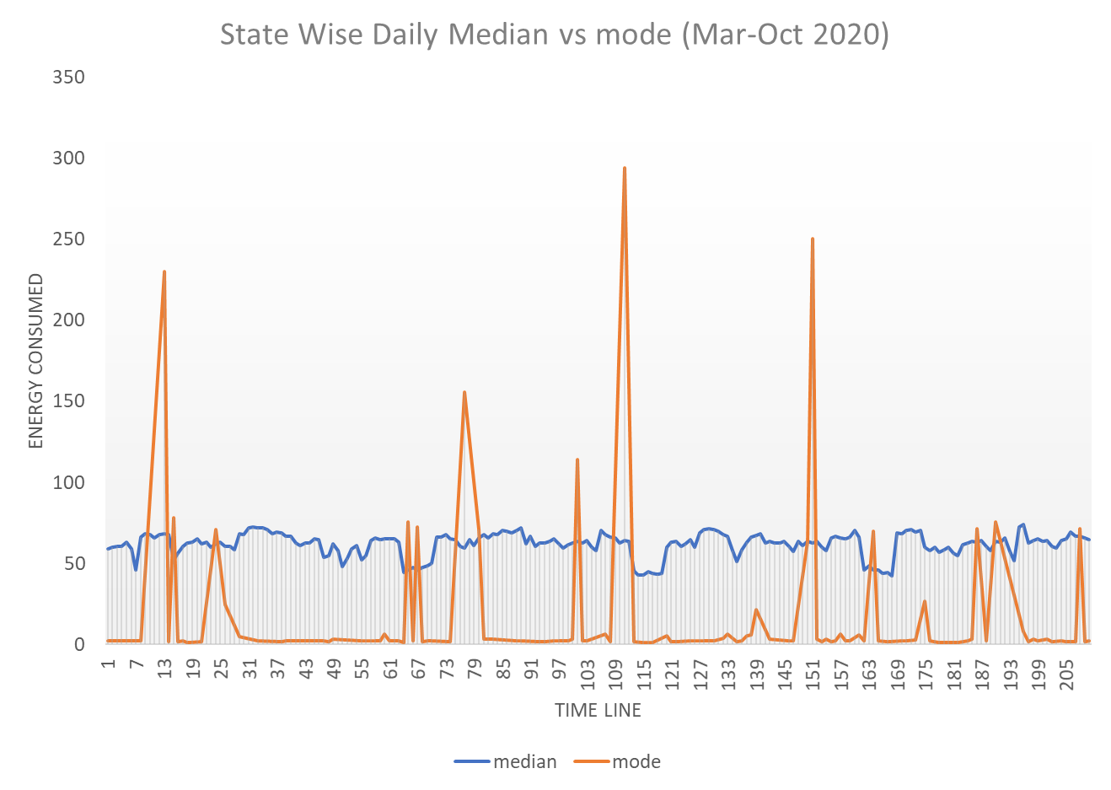

Figure 7 Mode vs median for Indian Data

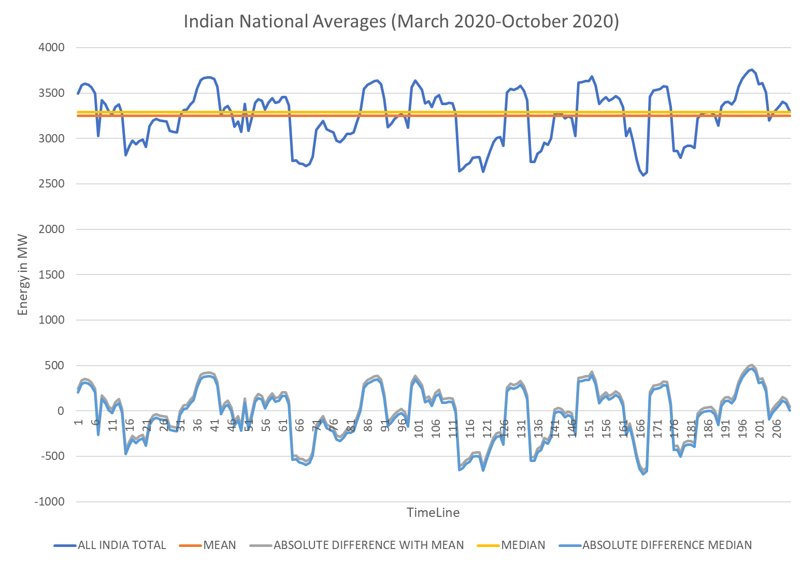

Figure 8 Mean, Median and mode for Indian Energy Consumption Data

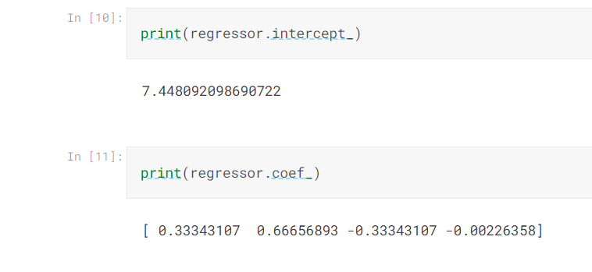

Figure 9 Linear Regression Used on Indian Data (For source Code, refer Appendix A)

If expressed through a table –

|  |  |
| --- | --- |
| Total Energy consumed over all time in India in 2019 | 682414.4 MW |
| Total of all median energy consumed | 690964 MW |
| Total of mean energy consumed | 682414.3 MW |
| Accuracy with mean at the end of year | 99.9% |
| Accuracy with median at the end of year | 98.76% |
| Error (Seasonal) for mean | ~ 4% |
| Error (Seasonal) for median | ~ 5% |
| Error with ARIMA | ~ 95% |
| Error with Linear Regression | ~ 50% |

**TABLE 3: Results with Estimating Energy Consumption in the Indian picture**

Which brings forth the following conclusions -

1. The mode is a very unstable factor among all the central tendencies.
2. India has a fairly steady energy usage pattern over the years, though seasonal usage varies considerably over regions (In fact, energy consumption patterns haven’t changed considerably during COVID as well).
3. The mean and median are fairly stable tendencies; however, median has a lower difference to the absolute value of the energy consumed and thus, the seasonal variance is lower.
4. While the nominal error for statistical centralities was close to 30%, the actual error at the end of the time interval was only 4%.

*So, among all central tendencies, median is the choice for the benchmark for generic Indian data.*

The same when employed for the more granular IIT Mumbai Dataset, the results were fairly similar with median being the computationally cheapest and most accurate benchmark.

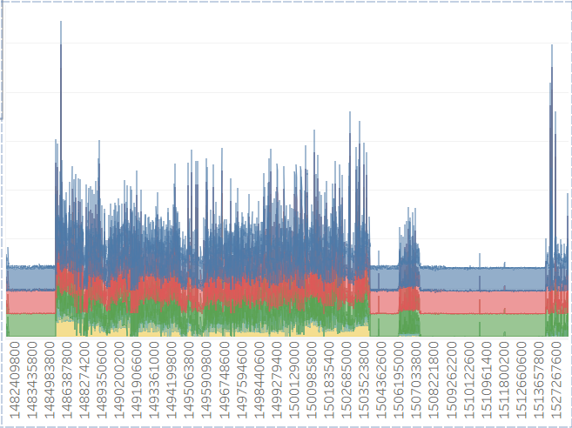

Figure 10 IIT Mumbai Energy Consumption by phase (hour wise)

### 7.1.2. New York Dataset

**Points to Note:**

1. New York, despite its small population, uses roughly 20 times more energy than Mumbai, 22 times more than Kolkata.
2. 40% of its energy is used in street lights, 90% of it is theoretically wasted given it could be saved by using LEDs (~6 million USD).

Now, for the sake of our project, the methodologies employed were ARIMA with and without a LSTM enforcement. And a basic centrality assessment using python.

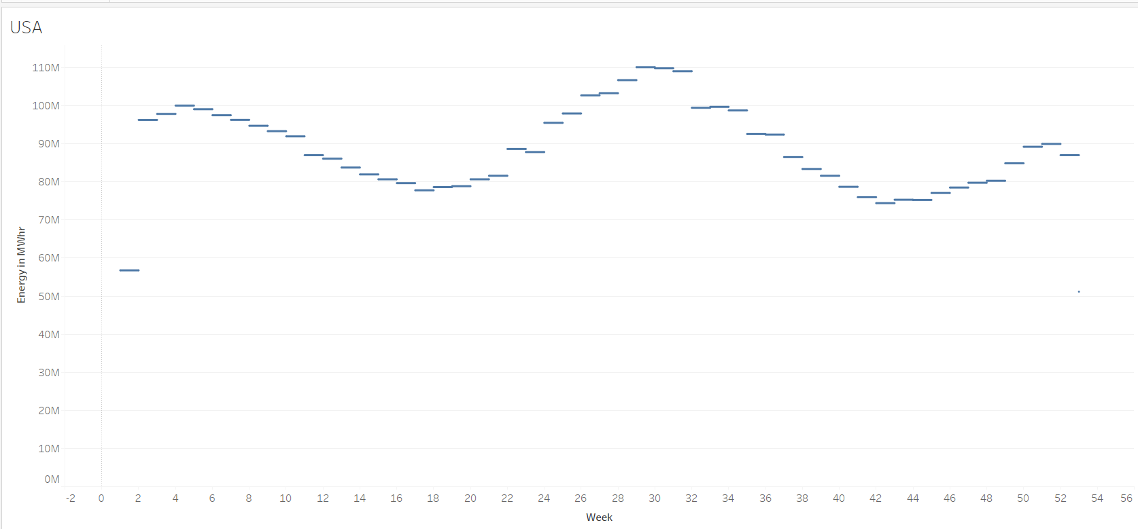

Figure 11 Energy Consumption pattern for New York

|  |  |
| --- | --- |
| Accuracy with mean (seasonal) | 92% |
| Accuracy with mean (at the end of year) | 95% |
| Accuracy with median (seasonal) | 94% |
| Accuracy with median (at the end of year) | 94% |
| Accuracy with ARIMA with LSTM | 96.2% |

**TABLE 4: Observations with Estimating Energy Consumption in New York**

### 7.1.3. London Dataset

**Point-to-note:** London spends 4 billion GBP in heating, 37-54% of which can be saved by simply insulating the century-old households.

Now, for our project, we used ARIMA with an LST enforced Neural Net and a simple statistical centrality calculation using Python. The results were -

1. ARIMA enforced with LSTM achieves an accuracy close to 97%.
2. The median’s accuracy was about 92%.

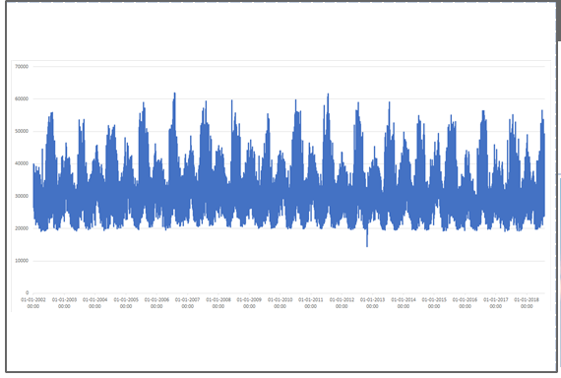

Figure 12 Energy Consumption Pattern for London

**TABLE 5: Observations with Estimating Energy Consumption in London**

|  |  |
| --- | --- |
| Accuracy with mean (seasonal) | 82% |
| Accuracy with mean (at the end of year) | 90% |
| Accuracy with median (seasonal) | 89% |
| Accuracy with median (at the end of year) | 93% |
| Accuracy with ARIMA with LSTM | 97.2% |

However, the computational cost of such an algorithm is very high when compared to statistical centralities when the scale of operation is considered.

*So, at the end, median is considered to be the final benchmarking paradigm for the project report.*

## 7.2. The results obtained from the CISCO Packet demonstration

The simulation generated in cisco packet tracer proves that -

1. The project is highly scalable and the IoT devices are easy to program.
2. The project is open to audit and inspection, ensuring data ethics and transparency.

## 7.3. Cost Estimate of Using the Proposed Algorithm in said scenarios

  One of the main objectives of the project was to develop a synergy between the economy of the project while also maintaining the required norms to develop a handsfree office.

### 7.3.1 Component and maintenance Cost for the Simulated Office

The following should summarise the cost of building and maintaining of the model in India.

**TABLE 6: IoT Components in the simulated scenario, their procurement costs and maintenance costs in India**

|  |  |  |
| --- | --- | --- |
| **Components Used** | **Purchase cost / Subsidy (if any)** | **Maintenance Cost (yearly)** |
| RFID | About 10,000 INR.  This has to be spent only once. | Battery lasts for an average of 4 years. And a general mechanic So, on an average, the maintenance cost is around 200 rupees per year. |
| Rain Sensor | 150 INR*4 | 2 years lifetime with minimum maintenance requirement. |
| Photo sensor | 1000 INR * 2 | 2 years lifetime with minimum maintenance requirement. |
| Solar Panels | 2 lakhs INR  (With 60% subsidy) | No maintenance needed for about 20-25 years. |
| Solar battery | 18000 INR (base) * 4 (number) | No maintenance needed for 5-7 years. |
| Active IR sensors | 400 INR - 500 INR | 2-3 years lifetime with minimum maintenance |
| Passive IR sensors | 100 INR - 200 INR * 3 | 3 years lifetime with little or no maintenance |
| Fire Alarm Sensors | 700 INR*5 | Maintenance every 6 months. The cost involved is the charge of the mechanic. |
| Fire Water Sprinkler | 1000 INR * 3 | Maintenance every 6 months. The cost involved is the charge of the mechanic |
| Programmable MCU | 300 INR | No maintenance needed for about 2-4 years |
| Bluetooth Speaker | 1200 INR | No maintenance needed for about 12-18 months. |
| Routers | 8000 INR | Maintenance once a year |

### 7.3.2. Extra Installation Cost for the simulated Office

These costs have to be borne only once.

**TABLE 7: IoT or electric devices to be installed without any foreseeable maintenance cost (in the simulated scenario)**

|  |  |
| --- | --- |
| **Office Space Module** | **Installation Costs involved** |
| Kitchen (requires Bluetooth speakers + music system) | 0 |
| Garage | About 14,000 INR |
| Coffee Vending + Fan | About 5000 INR |
| Street Lamp | About 8000 INR to construct the lamp |
| Theft Protection | About 2000 INR |
| Battery | About 2000 INR |
| Door Lock | About 10,000 INR for all the doors |
| Fire Alarm | About 5000 INR |

*Total cost of components and basic establishment is around 2,30,000 INR/office. These costs do not repeat themselves.*

Finally, installing a cloud may cost around 4.5 lakhs INR per year, which can be scaled down to about 2.8 lakh per year using a premise-based server.

However, since we are using a MQTT server, a limited server with even reduced costs may be used for the connections.

 So, the total cost of installation of the components including their base cost adds up to about 2.3 lakhs with an optional expenditure of about 3 lakhs per year depending upon the scaling of cloud the organisation needs.

### **7.3.3.** Comparison against real-time costs

As per research, the loss in productivity in Indian scenario is about 57% which is very high compared to only about 33% in the UK. Most of this is due to stress, anxiety and isolation. This also means that the costs involved in well-being increase both on the balance sheet of the company as well as the employee.

So, it is pretty apparent that a smart office is an urgent necessity.

1. The solar panel saves about 18 lakhs INR in electricity costs every year, given the scenario of India being a country rich in sunlight. In Arizona, USA - the savings are less, around 10000 USD per year (around 8,00,000 INR).
2. Elimination of any office staff responsible for relaying and carrying messages and files by digitizing everything saves around 8.5 lakh INR per year (given the basic bay of office clerks being around 2,40,000 INR per year in India). The savings increase in case of countries like the USA and the EU where minimum wages are higher.
3. Fire damages can cost a company about 30-90% of all its hardware and intellectual resources. This could also mean that a company could face heavy losses in future to re-establish systems. A fire alarm would be a very small investment given the possible losses. Business Sprinkler Alliance computes fire related losses to cost around 230 million pounds per year (about 2000 crore INR) in the UK alone.

All this means that using the proposed model is way more cost efficient than a regular office set up with all the installation costs covered up in about 2-3 years. After that, the organisation shall actually make profit with the organisational set-up and the smart office model proposed.

### 7.3.4. Summarising the Simulation

1. We propose a smart office model that is profitable and safe to work in the midst of the COVID-19 crisis. The model would yield profits from about the 3rd year of installation. This is with the assumption that company earnings remain steady and other volatile factors are constant.
2. In the 1st and 2nd year, it shall serve as a reason for higher productivity, reduced mental anxiety at work place and shall thus aid in absolute profits from the 2nd year itself.
3. We discuss the setting cost, variables and sensors involved.
4. We also contribute in our part to the spirit of environment protection, by suggesting a profitable model based on renewable and non-polluting energy sources.

# 8. SUMMARY

The algorithm thus proposed has been tested on real-world data with real-world cost of components involved in simulating a very common scenario in the world – an office. The authors feel confident that the algorithm thus proposed has a strong possibility to fill in the gaps experienced in the modern set-up of smart cities and the general outlook towards IoT devices. It should also help in reducing energy wastage, over-consumption or excess-dissipation of the same.

The author also would like to point out that the project proposed is the algorithm and hence, when deployed on a large server with a dataset of equivalent to the population of a small city/town or a large city like the ones in our case studies and with the granularity of a household or office, the means to assess the data might change.

# 9. REFRENCES

[1] Prince Waqas Khan, Yung-Cheol Byun, et al., “Machine Learning-Based Approach to Predict Energy Consumption of Renewable and Nonrenewable Power Sources”, 17 September 2020

[2] Mel Keytingan M. Shapi, Nor Azuana Ramli, Lilik J. Awalin, “Energy consumption prediction by using machine learning for smart building: Case study in Malaysia”, Developments in the Built Environment, Volume 5, 2021, 100037, ISSN 2666-1659

[3] Seyedzadeh, S., Rahimian, F., Glesk, I. et al. “Machine learning for estimation of building energy consumption and performance: a review”. Vis. in Eng. 6, 5 (2018)

[4] Zhijian Liu, Di Wu, Yuamwei Liu, et al., “Accuracy analyses and model comparison of machine learning adopted in building energy consumption prediction”, Sage Journals, Volume 37, Issue 4, January 2019

[5] A. Javed, H. Larijani and A. Wixted, "Improving Energy Consumption of a Commercial Building with IoT and Machine Learning," in IT Professional, vol. 20, no. 5, pp. 30-38, Sep./Oct. 2018, doi: 10.1109/MITP.2018.053891335.

[6] A. Nasser and V. Simon, "A Novel Method for Analyzing Weather Effect on Smart City Traffic," 2021 IEEE 22nd International Symposium on a World of Wireless, Mobile and Multimedia Networks (WoWMoM), 2021, pp. 335-340, doi: 10.1109/WoWMoM51794.2021.00061.

[7] B. Angel and D. Angel, "A Systematic Survey on the use of Fuzzy Graph Structures in India’s Smart City Development," 2021 5th International Conference on Computing Methodologies and Communication (ICCMC), 2021, pp. 1249-1253, doi: 10.1109/ICCMC51019.2021.9418353.

[8] Gusul, Procopie & Butnariu, Alina-Ramona, “EXPLORING THE RELATIONSHIP BETWEEN SMART CITY, SUSTAINABLE DEVELOPMENT AND INNOVATION AS A MODEL FOR URBAN ECONOMIC GROWTH”, The Annals of the University of Oradea. Economic Sciences, 2021

[9] Fagadar, Carmen & Trip, Diana & Darie, Gavrilut & Badulescu, Daniel, “SMART CITIES AND THE EUROPEAN VISION” The Annals of the University of Oradea. Economic Sciences, 2021

[10] Y. Alayza, J. Singer and A. L. Michala, "Optimizing Task Allocation for Edge Micro-Clusters in Smart Cities," 2021 IEEE 22nd International Symposium on a World of Wireless, Mobile and Multimedia Networks (WoWMoM), 2021, pp. 341-347, doi: 10.1109/WoWMoM51794.2021.00062. [11] Furdík, Karol & Lukac, Gabriel & Sabol, Tomas & Kostelnik, Peter, “The Network Architecture Designed for an Adaptable IoTbased Smart Office Solution”, International Journal of Computer Networks and Communications Security. 1. 216-224.

[12] H. Chourabi et al., "Understanding Smart Cities: An Integrative Framework," 2012 45th Hawaii International Conference on System Sciences, 2012, pp. 2289-2297, doi: 10.1109/HICSS.2012.615.

[13] Taewoo Nam and Theresa A. Pardo, “Conceptualizing smart city with dimensions of technology, people, and institutions”, Proceedings of the 12th Annual International Digital Government Research Conference: Digital Government Innovation in Challenging Times, Association for Computing Machinery, New York, NY, USA, 282–291.

[14] Gusul, Procopie & Butnariu, Alina-Ramona, “EXPLORING THE RELATIONSHIP BETWEEN SMART CITY, SUSTAINABLE DEVELOPMENT AND INNOVATION AS A MODEL FOR URBAN ECONOMIC GROWTH”, The Annals of the University of Oradea. Economic Sciences, 2021.

[15] Furdík, Karol & Lukac, Gabriel & Sabol, Tomas & Kostelnik, Peter, “The Network Architecture Designed for an Adaptable IoTbased Smart Office Solution”, International Journal of Computer Networks and Communications Security. 1. 216-224, 2013

[16] Pérez-delHoyo, Raquel & Mora, Higinio & PAREDES, JOSÉ, “USING SOCIAL NETWORK DATA TO IMPROVE PLANNING AND DESIGN OF SMART CITIES”, 171-178. 10.2495/UG180161, 2013.

[17] Á. Oliveira and M. Campolargo, "From Smart Cities to Human Smart Cities," 2015 48th Hawaii International Conference on System Sciences, 2015, pp. 2336-2344, doi: 10.1109/HICSS.2015.281.

[18] <https://online.hbs.edu/blog/post/data-ethics> (accessed on 10th March 2022)

[19] Floridi Luciano and Taddeo Mariarosaria, 2016, “What is data ethics?” *Phil. Trans. R. Soc. A.*3742016036020160360

[19] A vision of smarter cities, IBM Institute for Business Value (<https://www.ibm.com/downloads/cas/2JYLM4ZA>)

[20] T F Prasetyo et al 2018,  *“J. Phys.: Conf. Ser. 1013 012189 Prototype of smart office system using based security system”*

[21] Dony Susandi et al 2017, *“SMART PARKING SYSTEM PADA PROTOTYPE SMART OFFICE BERBASIS INTERNET OF THINGS”*

[22] Ping Shum et al 2018, “*Smart Office: A Voice-controlled Workplace for Everyone”*

[23] Arnau Erola et al 2015, *“Smart Insiders: Exploring the Threat from insiders using the Internet-of-Things”*

[24] Jianli Pan et al 2015, *“An Internet of Things Framework for Smart Energy in Buildings: Designs, Prototype, and Experiments”*

# APPENDIX A

## Basic Terminologies Involved in The Document

**MQTT**

*Introduction:*

Originally developed in 1999 to monitor oil and gas pipelines over remote satellite connections.

We have used the MQTT protocol because -

1. Lightweight;
2. Publish-subscribe messaging transport model;
3. designed for the constrained devices and with low bandwidth, easy for communication between multiple devices

**IEEE 802.11N**

Standard protocol for Wi-Fi 4.0

Uses multiple antennas and multiple nodes to reduce the probability of any dead point. This makes it a cost-effective protocol as compared to protocols that rely on stronger signals. So, IEEE802.11n fits perfectly with MQTT.

**Bluetooth**

Bluetooth is a wireless networking protocol that uses radio waves in the bandwidth 2.402 to 2.48 GHz. Typically has a maximum range of 10m.

## Selected Literature Survey

|  |  |  |  |  |  |  |
| --- | --- | --- | --- | --- | --- | --- |
| **S. No.** | **Title** | **Authors** | **Year** | **Advantages** | **Disadvantages** | **Scope for future work** |
| 1 | Machine Learning-Based Approach to Predict Energy Consumption of Renewable and Nonrenewable Power Sources | Prince Waqas Khan *et al.* | 2020 | Compared many load forecasting methods using ML.  Another advantage is the models used are compared to hybrid models  Moreover simple ML models are used such as Mean absolute error, mean squared error, mean absolute percent error, etc. | The logarithmic error is high.  Very simple mathematical models are used making the readings absolute.  The idea is based on statistics with no further futuristic use. | The models can be made logarithmic rather than regressive.  The data is considered for only a single space, and could be made better for better regression.  Could be used hybrid models as well. |
| 2 | Energy consumption prediction by using machine learning for smart  building: Case study in Malaysia | Mel Keytingan M. Shapi *et al.* | 2021 | The data collected is for a shopping district that is a very large sample.  Skewness and kurtosis values are accrued for the model making it future proof.  Accuracy is very high ranging between 90-92% | The models k-NN, SVM, ANN were used in accordance with which are not compatible with each other, and were used as comparators rather than providing solutions.  The data testing was normal, which reduces the accuracy of kurtosis.  Model development environment is time consuming. | The project takes too much time to emulate SVM hence a faster system could make the data more sublime and ecstatic.  Rather than using three different models, using hybrid versions will be better. |
| 3 | Machine learning for estimation of  building energy consumption and  performance: a review | Saleh Seyedzadeh *et al.* | 2018 | Was based on electric and solar energy.  Showed the comparisons using various sensors and IoT devices with energy conservation over a long time. | Here they have also used the SVM model hence increasing the computation time.  GP modelling making the cost inefficient | Simpler models used due to computation limits, could be improved with better systems.  Need an hybrid model for better accuracy as the number of variables increase with IoT devices and sensors. |
| 4 | Accuracy analyses and  model comparison of  machine learning adopted  in building energy  consumption prediction | Zhijian Liu *et al.* | 2019 | Here ANN and SVM are used and also made use of their hybrid, making improvements in previous papers  Since the sample of the data is very large making data more reliable as well. | Since computation of SVM is already hard, making hybridization harder.  Though the accuracy for the hybrid is high, the computation time is very slow. | The model can be introduced to fewer constraints, which could make the computation faster.  Model structure although simple has many flaws, could be introduced to better structural models. |
| 5 | Improving energy consumption of commercial building with IoT and machine learning | Javed *et al.* | 2018 | Neural networks were embedded with IoT subsystems.  It predicted 68% reduced cost effectiveness over a period of 10 years. | IoT sub-systems used were expensive and expansive, leading to inflated results.  On a minor scale the project was based on a complex leading to miss aligned perpetuations in the result as well. | Simpler IoT devices could be used, as they are cost effective, and easier to install and maintain.  The models used for future prediction are simpler using random neural networks.  Since smaller sensors could also be used, solar energy could also be incorporated to make profits soar even higher. |
| 6 | A Novel Method for Analysing Weather Effect on  Smart City Traffic | Aram Nasser and Vilmos Simon | 2021 | Made use of many real-life variables such as wind, sunlight and rain;  This gave us the idea to implement a real-life visualisation model for the project. | The models used advanced statistical models for rain variables and others. | The model could be simpler.  Sensors used could be better. |
| 7 | A Systematic Survey on the use of Fuzzy Graph  Structures in India’s Smart City Development | B. Angel and D. Angel | 2021 | FGS model was used making the system future proof.  Graphs make connectivity easier and vivid. | More inclined towards urban spaces only.  Require precise network hence not cost effective. | Can be made more inclined to energy savings rather than quality of life.  Needs to be more cost effective. |
| 8 | Exploring The Relationship Between Smart City, Sustainable Development and Innovation.As A Model For Urban Economic Growth | Procopie Florin Gușul  and Alina Ramona Butnariu | 2021 | Easy explanation of interdependence of economy and innovation.  Gave better scope for our own project. | Was completely theoretical, had less mathematical models involved. | Could introduce better results.  Data samples were scarce, and needed more data for future integrations. |
| 9 | Smart cities and the European Vision | Carmen Florina Fagadar *et al.* | 2021 | Compared many semi-urban and urban spaces of many scoops of notions including both developing and developed.  Good sample space, making comparisons easy to frame and understand. | Solutions in the problems were more inclined towards colder regions;  Lacked diversification in results.  Was majorly theoretical;  Lacked mathematical and statistical models. | Integrating ML will take the study to greater heights.  Need more solutions to semi- urban and suburban regions.  Lacking a practical approach hence could introduce theoretical variables for better future results. |
| 10 | Optimizing Task Allocation for Edge Micro-Clusters in Smart Cities | Yousef Al Hailey et al. | 2021 | The resource management for clusters is reduced to a mixed integer problem.  Greedy algorithm is employed to create the most energy-efficient cluster head selection protocol.  The makespan is minimised. | The scope of the project is too large to be evaluated using a quasi-realistic setup on breadboards.  As a consequence, the model proposed is not generic. | Scaling up the model to be functional in IoT environments other than just Raspberry Pi would help generalize the model and implement it in more varied and realistic situations. |
| 11 | The Network Architecture Designed for an Adaptable IoT-based Smart Office Solution | Karol Furdik et al. | 2013 | A balanced approach towards the human needs of an IoT-enabled office space is taken into consideration.  The audit of data is possible and the result is a cost-effective solution. | The major drawback is the lack of specialisation of IoT services. Different IoT services are required in different rooms and spaces. This project only explores a limited set of users and rooms. | Creating solutions more compatible with individual requirements. |
| 12 | Understanding Smart Cities: An Integrative Framework | Hafedh Chourabi,Taewoo Nam,Shawn Walker,J. Ramon Gil-Garcia,Sehl Mellouli,Karine Nahon,Theresa A. Pardo,Hans Jochen Scholl | 2012 | One of the very few papers which takes into consideration various countries at once  Various challenges to the creation of a smart city such as technical,managerial,organisational etc. have been identified  Rich literature has been considered  Clear and concise | More visual and diagrammatic representations  are required so as to address rather complex topics  Lack of examples of real-world smart cities,rather countries and their current scenarios are considered | Case study of current smart cities can also be discussed  More diagrams and flowcharts can be added so as to make the information more appealing to the readers |
| 13 | Conceptualising Smart City with Dimensions of Technology, People, and Institutions | Taewoo Nam & Theresa A. Pardo | 2011 | More focus on the fundamental building blocks of smart cities  Real-world smart cities have been discussed | Different types of smart cities have been mentioned such as ubiquitous cities,hybrid cities,wired cities etc.,but no brief description is given  The paper lacks in depth analysis of smart cities,it offers a more broader analysis of the same | Brief discussion about the different types of smart cities  In-depth analysis of the various intricacies involved in the creation of a smart city |
| 14 | Exploring The Relationship Between Smart City, Sustainable  Development And Innovation As A Model For Urban Economic  Growth | Procopie Florin Gușul, Alina Ramona Butnariu | 2021 | Recent work makes the study more likely to chosen as a part of literature  Focuses on the environmental impact of smart cities | Lack of information regarding the environmental impact of smart cities  The literature hasn’t been utilised properly | Proper analysis of scholarly articles can give new insights  Brief discussion about the environmental impact of smart cities |
| 15 | The Network Architecture Designed for an Adaptable IoT-based Smart Office Solution | Karol Furdik et al. | 2013 | A balanced approach towards the human needs of an IoT-enabled office space are taken into consideration.  The audit of data is possible and the result is a cost-effective solution. | The major drawback is the lack of specialisation of IoT services. Different IoT services are required in different rooms and spaces. This project only explores a limited set of users and rooms. | Creating solutions more compatible with individual requirements. |
| 16 | Using Social Network Data To Improve Planning And Design Of Smart Cities | Raquel Pérez-del hoyo , Higinio Mora & José Francisco Paredes | 2018 | Clear and concise  The aspect studied is generally liked by readers | Lack of literature survey;  Insufficient data visualisations; | Proper literature survey can be done  Addition of more visualisations will give a more detailed study touch to the work |
| 17 | From Smart Cities to Human Smart Cities | Álvaro Oliveira,Margarida Campolargo | 2015 | Eye catching topic has been studied  Not much relevant literature exists,as a result, addition of this work will greatly benefit future readers | Although challenges have been identified in this paper,the solutions to handle the same aren’t present in sufficient amount;  Since the My-Neighbourhood project was implemented in only 4 cities,as a result,it is difficult to believe that the same conclusions are valid for other cities as well | More focus on the methods to tackle the challenges identified  Discussion about the results from different projects can be included |

## Link to tableau presentation

<https://public.tableau.com/views/EnergyTrendsViz/CoverPage?:language=en-US&:display_count=n&:origin=viz_share_link>